APDA Virginia Optimism Walk
Saturday June 3rd, 2023
Warhill Sports Complex, Williamsburg, VA
2023 Sponsorship Proposal
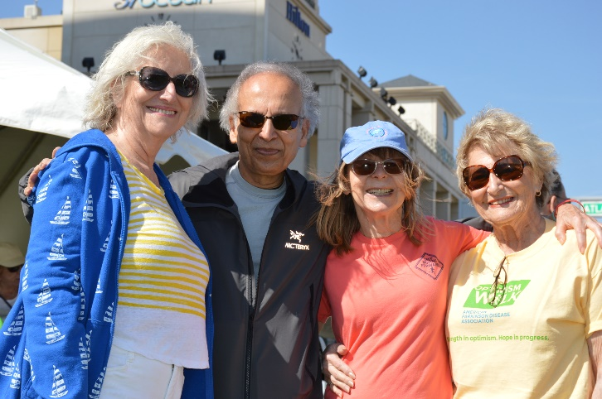
CONTACT:
Kathryn Wiesmann, Chapter Coordinator
757-495-3062
kwiesmann@apdaparkinson.org
www.apdaparkinson.org/va
______________________________________________________________________________________________________________________________
APDA Optimism Walk
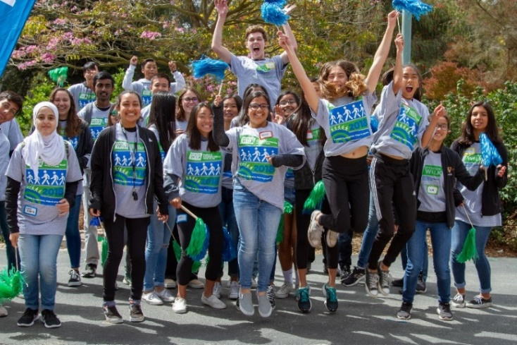
_____________________________________________________________________________________________
We are excited for the 2023 APDA Optimism Walk season!
The Optimism Walk is a family-friendly fundraising event that offers a short walk and an important opportunity for friends, families, and individuals coping with Parkinson's to take their passion and concern and turn it into a positive experience aimed to help end Parkinson’s disease.
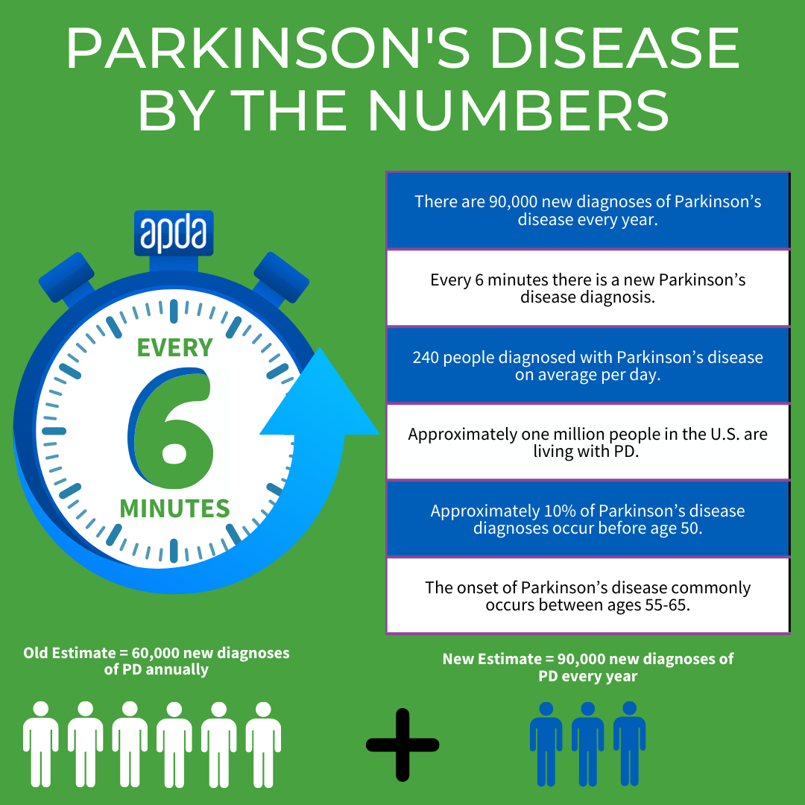
Join us for a fun day filled with inspiration, hope, and a great sense of community! Funds raised will enable APDA to continue providing information, education, and support to those impacted by PD and fund scientific research into the causes, prevention, treatments and ultimately the cure. APDA will follow public health guidelines to ensure all our participants have a safe and comfortable event experience.
Every dollar raised makes an important difference. The more funds we raise, the more people we can help.
Our goal is 250+ participants and $60,000 raised for the American Parkinson Disease Association.
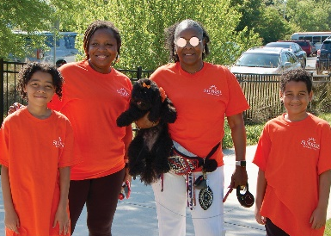
Participants and sponsors are encouraged to share photos and stories of the day using #OptimismWalk to show strength in optimism and hope in progress.

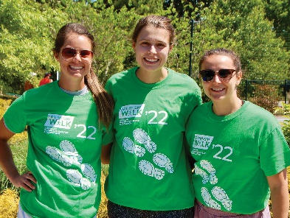
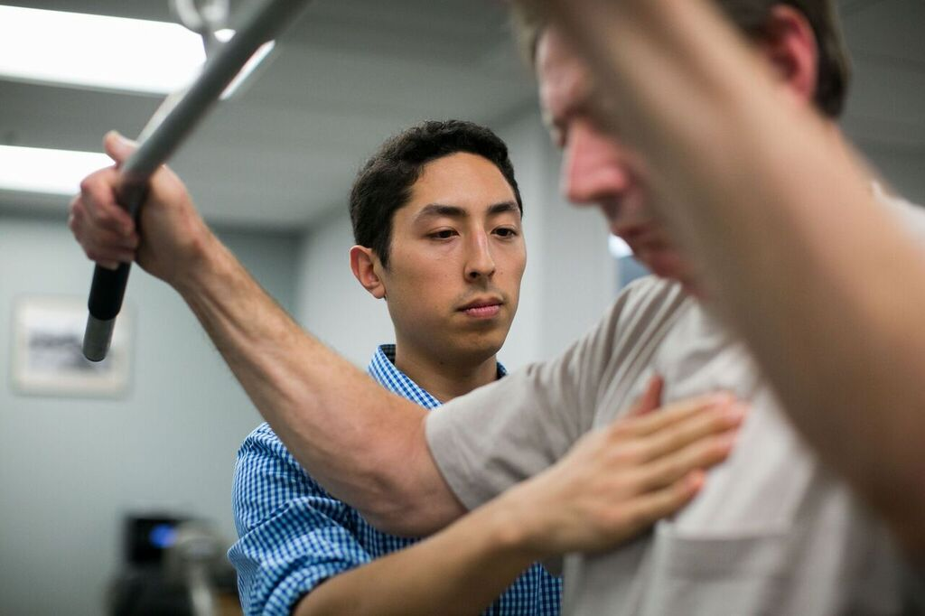
Your Sponsorship at Work
Funds raised at the 2023 Virginia Optimism Walk will be used to expand local programs and services so we can help more people with PD in Virginia live life to the fullest. Funds also support cutting-edge research that will help us find better treatments and get us closer to a cure.
APDA Mission & Vision:
Every day, we provide the support, education and research that will help everyone impacted by Parkinson’s disease live life to the fullest.

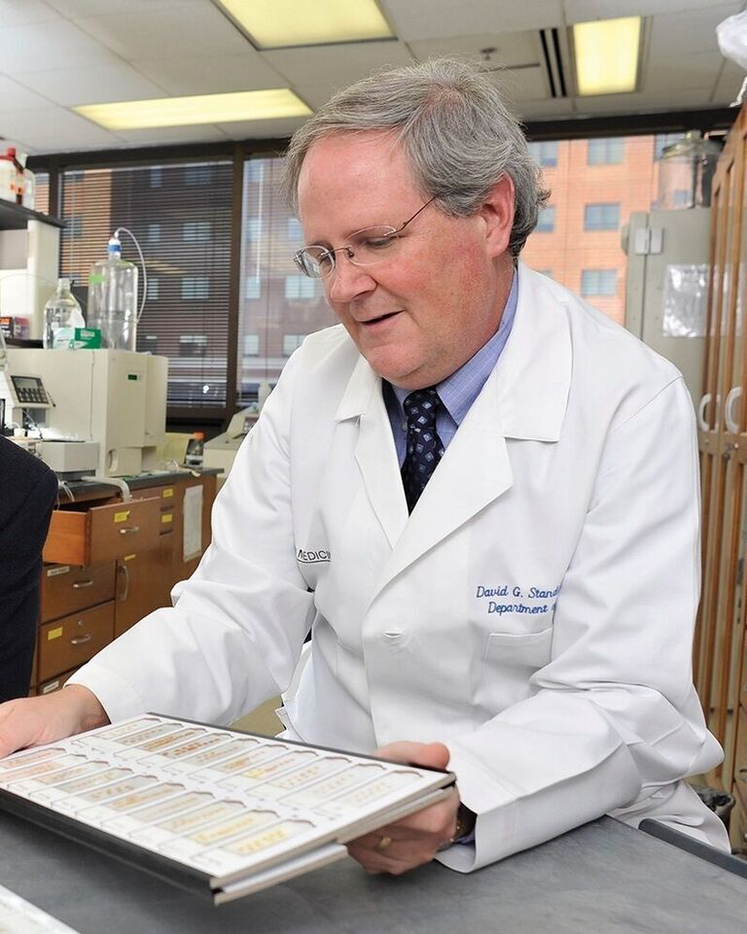

About APDA (nationally):
The American Parkinson Disease Association (APDA) is the largest grassroots network dedicated to fighting Parkinson’s disease (PD) and works tirelessly to help the more than 1 million Americans with PD live life to the fullest in the face of this chronic, neurological disorder. Founded in 1961, APDA has raised and invested more than $226 million to provide outstanding patient services and educational programs, elevate public awareness about the disease, and support research designed to unlock the mysteries of PD and ultimately put an end to this disease. This is done through a nationwide network of Chapters and Information & Referral (I&R) Centers, as well as a national Research Program and Centers for Advanced Research.

About APDA in Virginia:
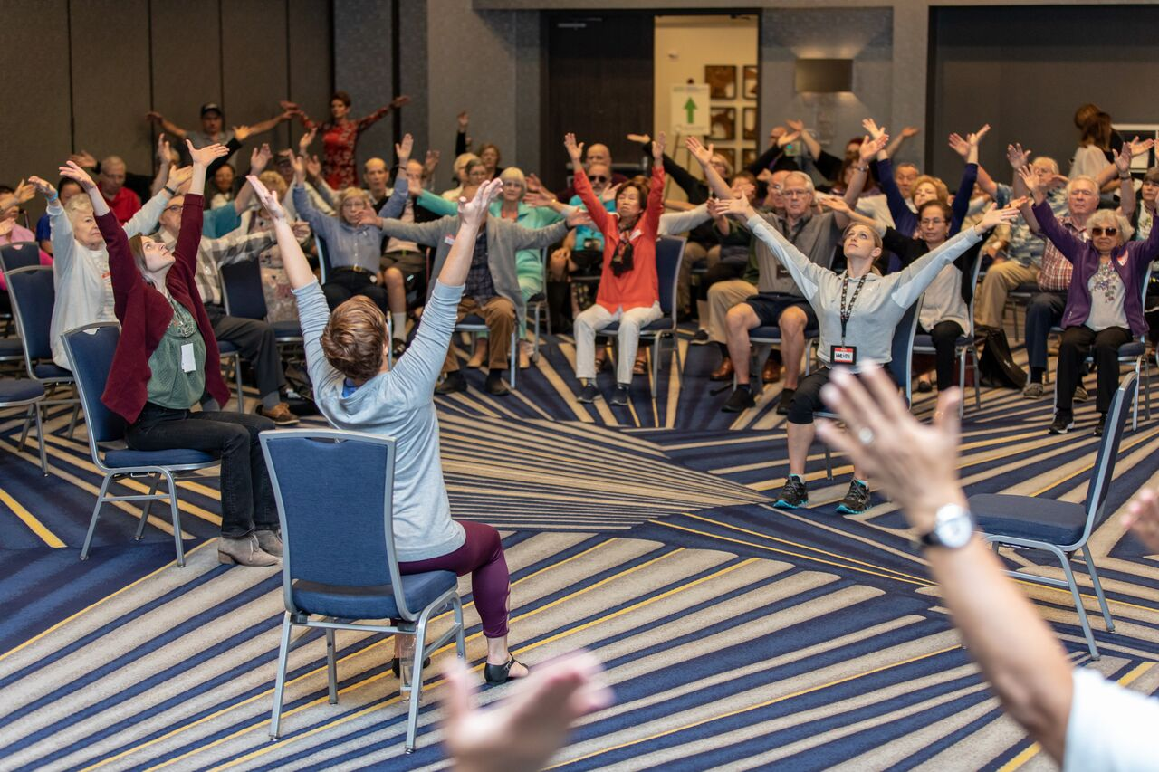
APDA has a long, strong history in Virginia having supported more than 7,000 members of the Parkinson’s community. The support we receive from the community we recycle directly back into programs, special events, and everyday services to help manage living well with Parkinson’s. In the past year, APDA Virginia has been able to provide virtual and in-person patient and provider educational programming, community referrals via a telephone helpline, a statewide resource and exercise support program, social events for people living with PD and care partners, and much needed financial support through a scholarship application. Funds raised by this Optimism Walk will be used towards expanding coverage to more locations in Virginia and support an even stronger network of offerings for the local PD community in the coming years.

APDA Virginia Optimism Walk Sponsorship Opportunities
___________________________________________________________________________________

 | Platinum | Gold | Silver | Bronze
Support Level | $7,500 | $5,000 | $2,500 | $1,000
Pre-Event Recognition & Benefits*
Logo with hyperlink included on Chapter’s Optimism Walk event web page to sponsor’s corporate web page | Premium Placement  Large Logo | Medium Logo | Small  Logo | Name
Dedicated recognition banner on Chapter’s Optimism Walk event web page | ✓  2 weeks | ✓  1 week
Exposure in autoresponder when individuals register or reach fundraising milestones | Premium placement large logo | Medium Logo | Small  Logo | Name
Placement on local printed materials (brochure, and/or flyer; name-only on postcard due to space limitations) | Premium Placement  Large Logo | Medium Logo | Small  Logo
Mention in social media post(s) on Chapter Facebook page | up to 3 | up to 2 | Once
Inclusion in local Walk press release | ✓ | ✓
Placement on locally distributed event t-shirts | Large  Logo | Medium Logo | Small  Logo
Use of Optimism Walk logo | ✓ | ✓ | ✓ | ✓
Placement in APDA Walk email communications | Premium Placement  Large Logo | Medium Logo | Small  Logo | Name
Event Day Recognition & Benefits **
Recognition on event signage | Premium Placement  Large Logo | Medium Logo | Small  Logo | Name
Recognition during Opening Ceremony/program announcements/DJ | ✓ | ✓ | ✓
Premium reserved exhibit placement opportunity near front entrance and registration to distribute premiums to participants and interact with your target audience. | ✓
Priority exhibit placement opportunity near registration to distribute premiums to participants and interact with your target audience |  | ✓
Opportunity to distribute premiums to participants and interact with your target audience |  |  | ✓ | ✓
Post-Event Recognition & Benefits
Recognition in local post-event communications and thank you materials | Premium Placement  Large Logo | Medium Logo | Small  Logo | Name
\
* Some benefits are subject to deadlines.
** Any health safety guidelines as indicated by APDA must be followed.

______________________________________________________________________________________________________________________________
2023 Virginia Optimism Walk Sponsorship Commitment Form
____________________________________________________________________________________
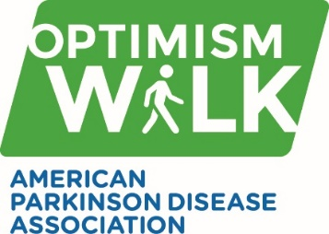
□ Platinum Sponsor ($7,500) □ Bronze Sponsor ($1,000)
□ Gold Sponsor ($5,000) □ Silver Sponsor ($2,500)
In-kind product donation of _________________________________ with a value of: $_______

SPONSOR/COMPANY NAME:
Contact Name:
Address:
City: |  |  | State: | Zip:
Phone: | Email:
Website:
Print Name & Title: |  | Print Name & Title:
Signature: |  | Signature:

Please email this Sponsor Commitment form and company logo(see below) to:
APDA Virginia Chapter
kwiesmann@apdaparkinson.org
For more information call: 757-495-3062
Checks to be made payable to APDA and mailed to: P.O. Box 4162, Virginia Beach, VA 23451
Click Here to pay via credit card or bank transfer or use the link below
https://tinyurl.com/APDAVaWalkDonate

IMPORTANT: Please email a high-resolution JPEGS(300dpi), PDFs or VECTOR ART FILES(.eps or .ai) logos as they print best on the shirts. Logos not supplied in these formats risk being blurry, fuzzy or unreadable.

Thank you for your commitment in sponsoring the Virginia Optimism Walk and helping APDA create a better future for those living with Parkinson’s disease!

