Grupo de Apoyo para Cuidadores

12 de enero del 2023
9 de marzo del 2023
11 de mayo del 2023
5:00PM-6:00PM (hora del este)
https://apdaparkinson.zoom.us/j/82331421134

Acompáñenos en una conversación sobre cómo ayudar a un ser querido a vivir y a manejar los síntomas de la enfermedad de Parkinson para tener la mejor calidad de vida posible. El programa está diseñado para ayudar a los familiares y cuidadores de personas con la enfermedad de Parkinson. Comparta esta invitación con cualquier persona de su red de apoyo que crea que se beneficiara de esta información. Ofrecemos la serie en español y en inglés (cada mes cambiará entre inglés y español). Este grupo es una colaboración entre la Universidad de Miami Miller School of Medicine y la Asociación Americana de Enfermedad de Parkinson (APDA).

Nuestros estimados expertos discutirán:
- Etapas, síntomas y como progresa la enfermedad de Parkinson con el tiempo
- Desafíos de ser cuidador
- Prácticas de auto cuidado
- Formas de ayudar a un ser querido

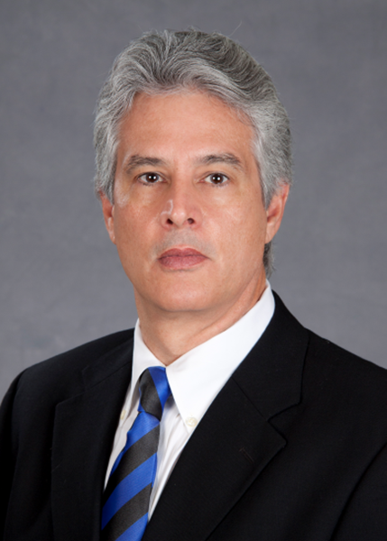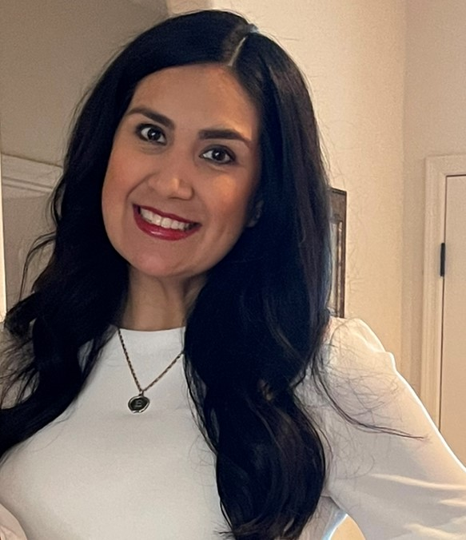
George Felix Dumenigo, LCSW Rosa Peña, MSW Laura Esquer, MS Licensed Clinical Social Worker Vice President, Programs & Services I&R Coordinator
Community Outreach Coordinator APDA APDA
Miami, Florida Los Angeles, California Yuma, Arizona

apdaparkinson.org Toll free: 1-800-223-2732
For questions: rpena@apdaparkinson.org

PARKINSON’S DISEASE: CHALLENGES TO MANAGEMENT IN MULTICULTURAL COMMUNITIES

