DAPpers
Dance for All People
Scandinavian Community
Mondays 2:00-3:00pm
Instruction by Rachel Balaban, Regional Coordinator for Dance for PD
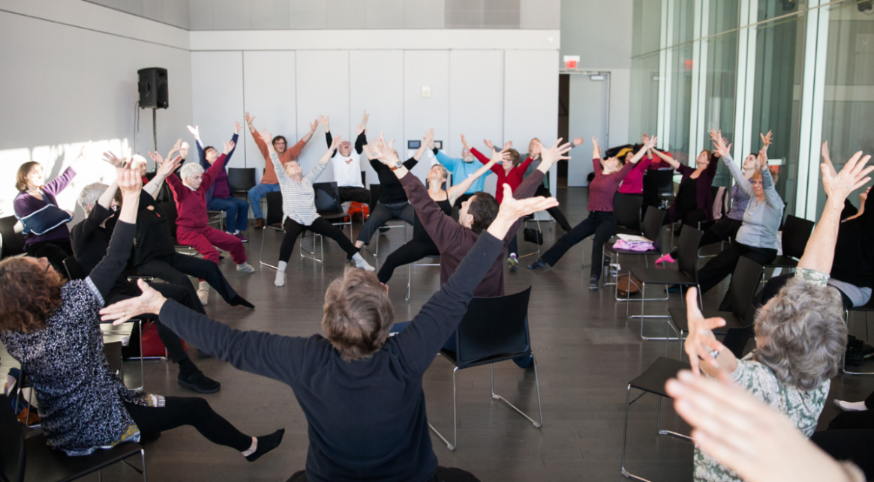

Class open to people of all ages and abilities and designed for people with movement challenges.
- Enhance your physicality — increase coordination and flexibility, strengthen core, and improve balance while releasing body tension
- Increase your bodily awareness
- Grow your support network — feel encouraged as you explore movement and socialize within a safe and comfortable zoom community
- Explore your creativity and have fun
No experience required. Caregivers welcome.

Contact: Justin Erban at jerban@carelinkri.org to register
Zoom Link: https://carelinkri-org.zoom.us/j/82405977011
This program is brought to you in part through the generosity of the Rhode Island Chapter of the American Parkinson’s Disease Association
www.apdaparkinson.org/community/rhode-island/

